

Semester 1 Examination 2011

Question/Answer Booklet

MATHEMATICS 3C/3D

Section One

(Calculator Free) Student Number

Name
Teacher ___________________________________

Time allowed for this section
Reading time before commencing work: 5 minutes
Working time for paper: 50 minutes

Material required/recommended for this section

To be provided by the supervisor
Question/answer booklet for Section One.
Formula sheet.

To be provided by the candidate
Standard items: pens, pencils, pencil sharpener, highlighter, eraser, ruler.
Important note to candidates
No other items may be taken into the examination room. It is your responsibility to ensure that you do not have any unauthorised notes or other items of a non-personal nature in the examination room. If you have any unauthorised material with you, hand it to the supervisor before reading any further.

Structure of this examination

 | Number of questions | Working time (minutes) | Marks available
This Section (Section 1)  Calculator Free | 6 | 50 | 40
Section Two  Calculator Assumed | 12 | 100 | 80
Total marks |  |  | 120

Instructions to candidates

- The rules for the conduct of WACE external examinations are detailed in the booklet WACE Examinations Handbook. Sitting this examination implies that you agree to abide by these rules.

- Answer the questions in the spaces provided.

- Spare answer pages are provided at the end of this booklet. If you need to use them, indicate in the original answer space where the answer is continued i.e. give the page number.

- Show all working clearly. Any question, or part question, worth more than 2 marks requires valid working or justification to receive full marks. If you repeat an answer to any question, ensure that you cancel the answer you do not wish to have marked.
Section One (calculator-free) 40 Marks
This section has five (5) questions. Answer all questions. Write your answers in the space provided.

Spare pages are included at the end of this booklet. They can be used for planning your responses and/or as additional space if required to continue an answer.
  - Planning: If you use the spare pages for planning, indicate this clearly at the top of the page.
  - Continuing an answer: If you need to use the space to continue an answer, indicate in the original answer space where the answer is continued, i.e. give the page number. Fill in the number of the question(s) that you are continuing to answer at the top of the page.

Suggested working time for this section is 50 minutes.

Question 1 [5 marks]
A function is defined by the rule y = f(g(x)), where f(x) = 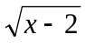 and g(x) = 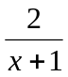.
- Determine the domain and range of:

  - g(x) [1]
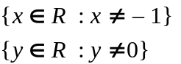


  - f(x) [1]
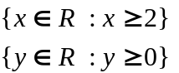


  - f(g(x)) [2]
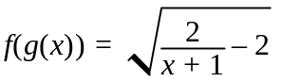

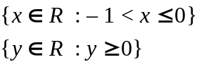

(b) Without substituting any values in f(g(x)), determine whether or not the point (1,1) lies on the curve defined by f(g(x)). [1]

No, since 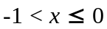

Question 2 (6 marks)
(a) Solve the equation below:
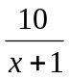 + 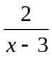 = 4 [3]
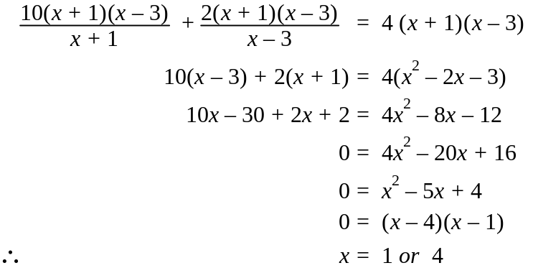



(b) Simplify: 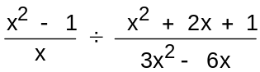 [3]
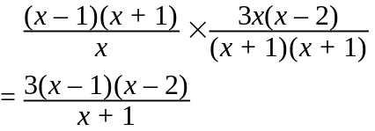




Question 3 (4 marks)
Find the maximum and minimum values over the interval 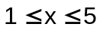 of the function
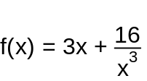
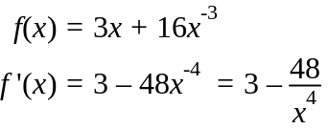

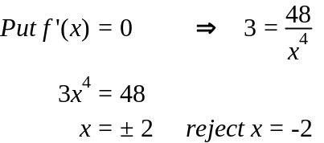

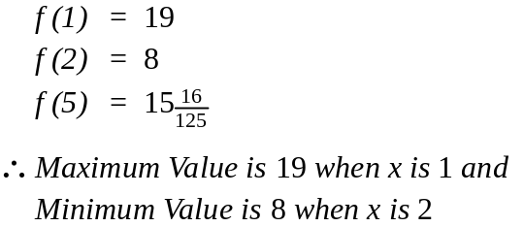


Question 4 (4 marks)
For each of the following find the derivative with respect to x:
(a) 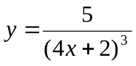 [2]
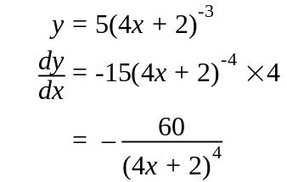


(b) 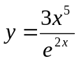 [2]
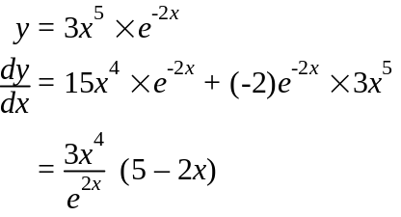


Question 5 (4 marks)
(a) Determine the following indefinite integral
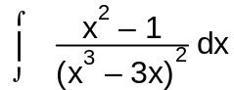 [2]

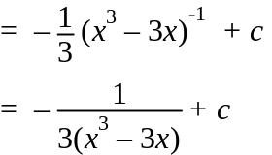


(b) Evaluate the following definite integral as an exact answer

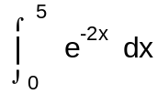 [2]
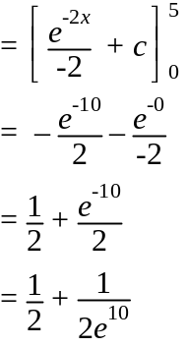



Question 6 (6 marks)
(a) The probabilities of two events A and B are given by:
Calculate 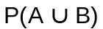, given that are independent. [3]

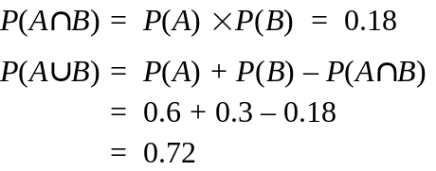


(b) R and S are events where P(R) =, P(S) = , and P(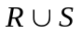) =.
- Find P(R|S) and P(S|R). [2]

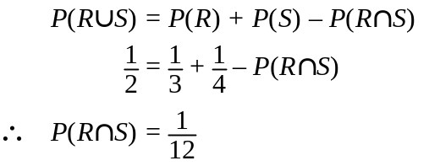
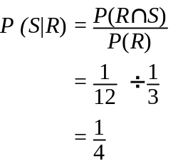
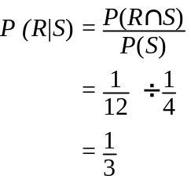



  - Are R and S independent? Give a reason. [1]

Yes they are independent. 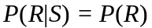


Question 7 (7 marks)

On the axes below, sketch the function f(x) = x³ – 9x² + 15x +25 showing any turning points, points of inflection and intercepts on axes.
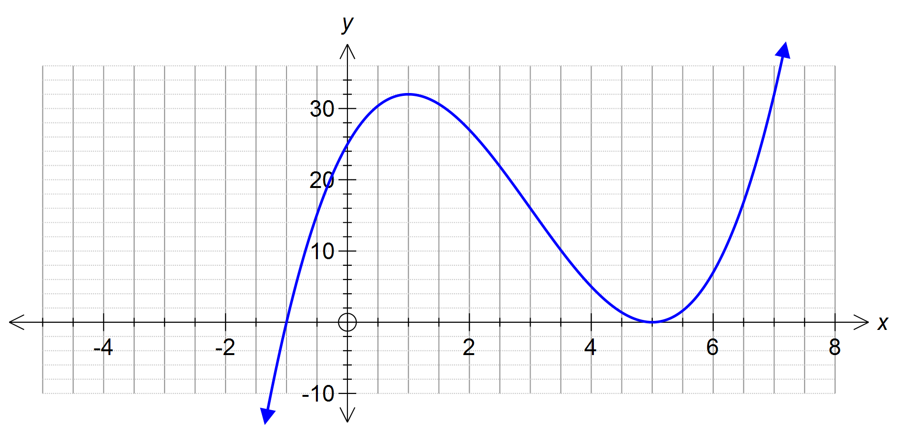y=x3-9x2+15x+25
f(x)




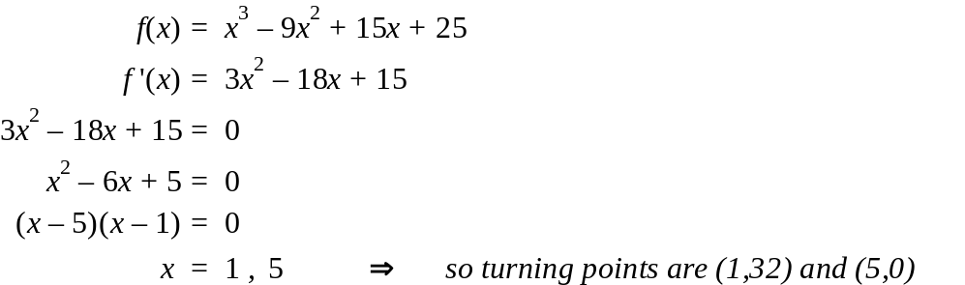



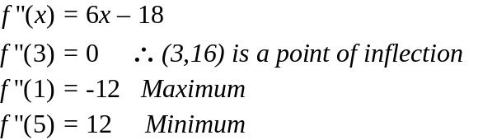

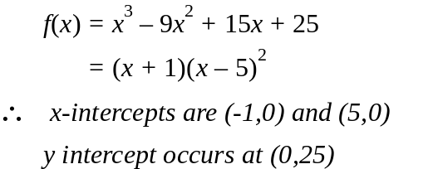


Question 8 (4 marks)

A fund-raising box of wrapped chocolates was left in a car on a hot day and 30% of them were melted. Three chocolates are selected at random.
What is the probability that:

(a) exactly two are melted? [DO NOT SIMPLIFY] [1]
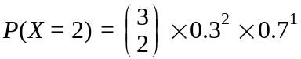


(b) at least one is melted? [DO NOT SIMPLIFY] [2]
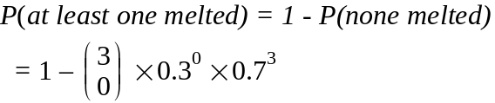



(c) two or more are melted? [DO NOT SIMPLIFY] ; [1]


